
Steps Podcast Creating website and code repository
A GitHub Repository should have code basis, a readme file and Official Document website

September 6, 2024
Progressive Pull INC

Contents
Installed Software 3
Git 3
Source Tree 3
NodeJS and NPM 4
GitHub Desktop 4
Visual Studio Code 5
First Steps creating Repository 5
Creating new GitHub Repository 5
Deciding on Name for New Repository 6
Create a New Repository 7
Select Public Type, Initialize README, Git Ignore, License 8
When you Added no files to Repository 10
or create a new repository on the command line 10
or push an existing repository from the command line 10
create a new repository on the command line tutorial 11
Open Visual Studio Code 11
Open Terminal Window 11
Create README with Echo (echo <text> >> <file_name>) 11
Initialize the Git Repository (git init) 12
Staging the README File (git add <file_name>) 12
Check what files are Staged 13
Committing the staged files (git commit -m “<message>”) 14
Using Source Tree to check the Git History 14
Creating Main Branch 15
Basic Branch Tasks 15
Switch between Branches 15
Merge Branches 16
Rename Branch (git branch -M <branch_name>) 17
Delete a Repository 17
README File 18
References 19
Markdown 19
Linux Commands 20

Installed Software
I’m not going to walk you through the installation process for this software. You can find plenty of tutorials on YouTube. Instead, I’ll provide you with a list of the software you need for your machine.

Git
Git is a free and open source distributed version control system designed to handle everything from small to very large projects with speed and efficiency.
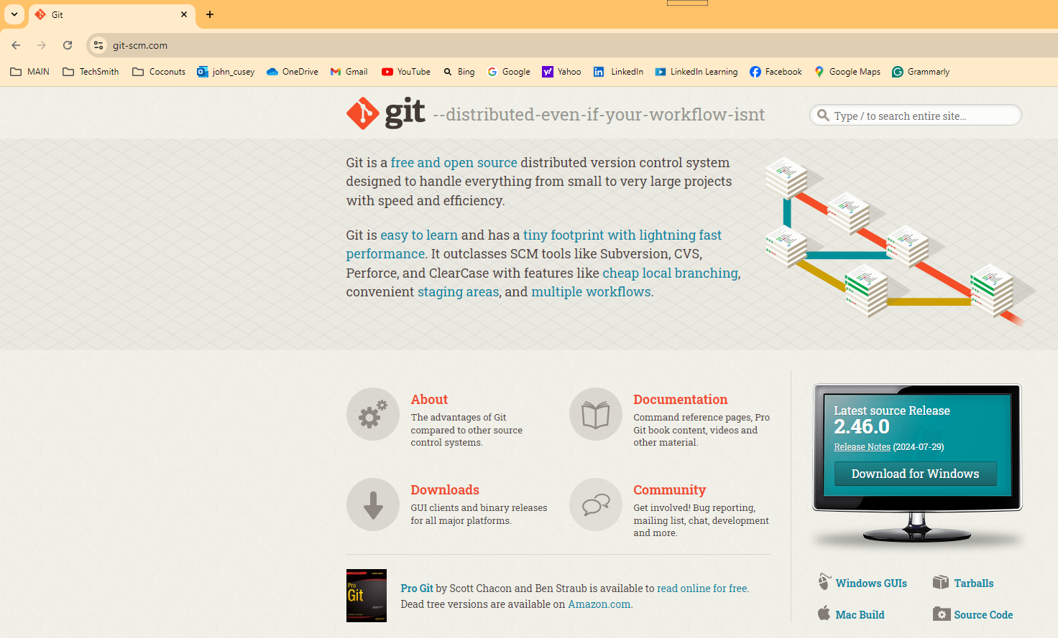
https://git-scm.com/

Source Tree
SourceTree simplifies how you interact with your Git repositories so you can focus on coding. Visualize and manage your repositories through SourceTree’s simple Git GUI.
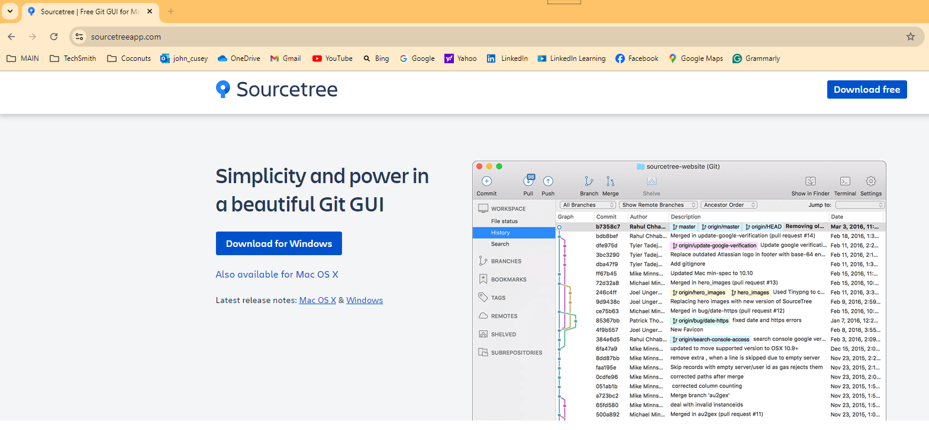
https://www.sourcetreeapp.com/

NodeJS and NPM
Node.js® is a free, open-source, cross-platform JavaScript runtime environment that lets developers create servers, web apps, command line tools and scripts. Node.js comes with npm, the standard package manager for Node.js
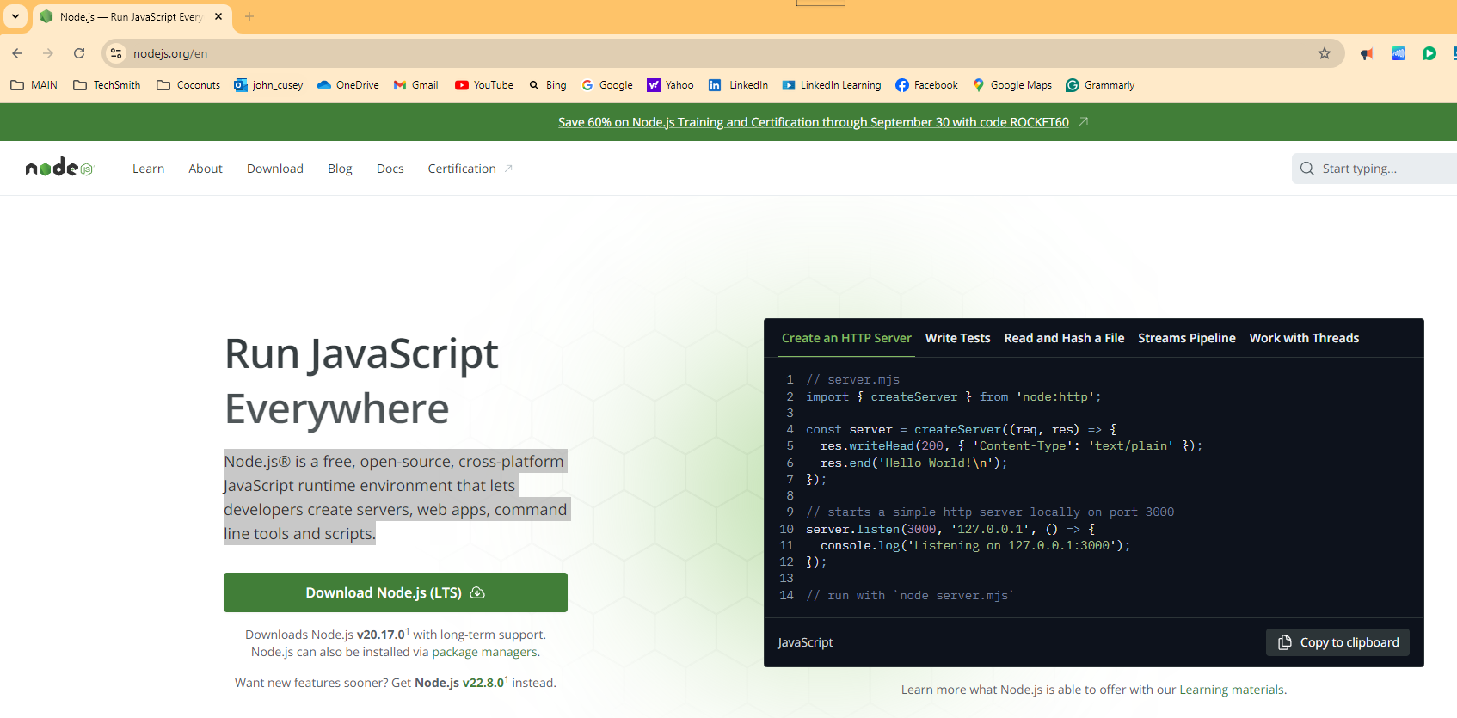
https://nodejs.org/en

GitHub Desktop
GitHub Desktop is a free and open-source application designed to simplify your development workflow. It allows you to interact with GitHub repositories using a graphical user interface (GUI) instead of the command line or web browser.
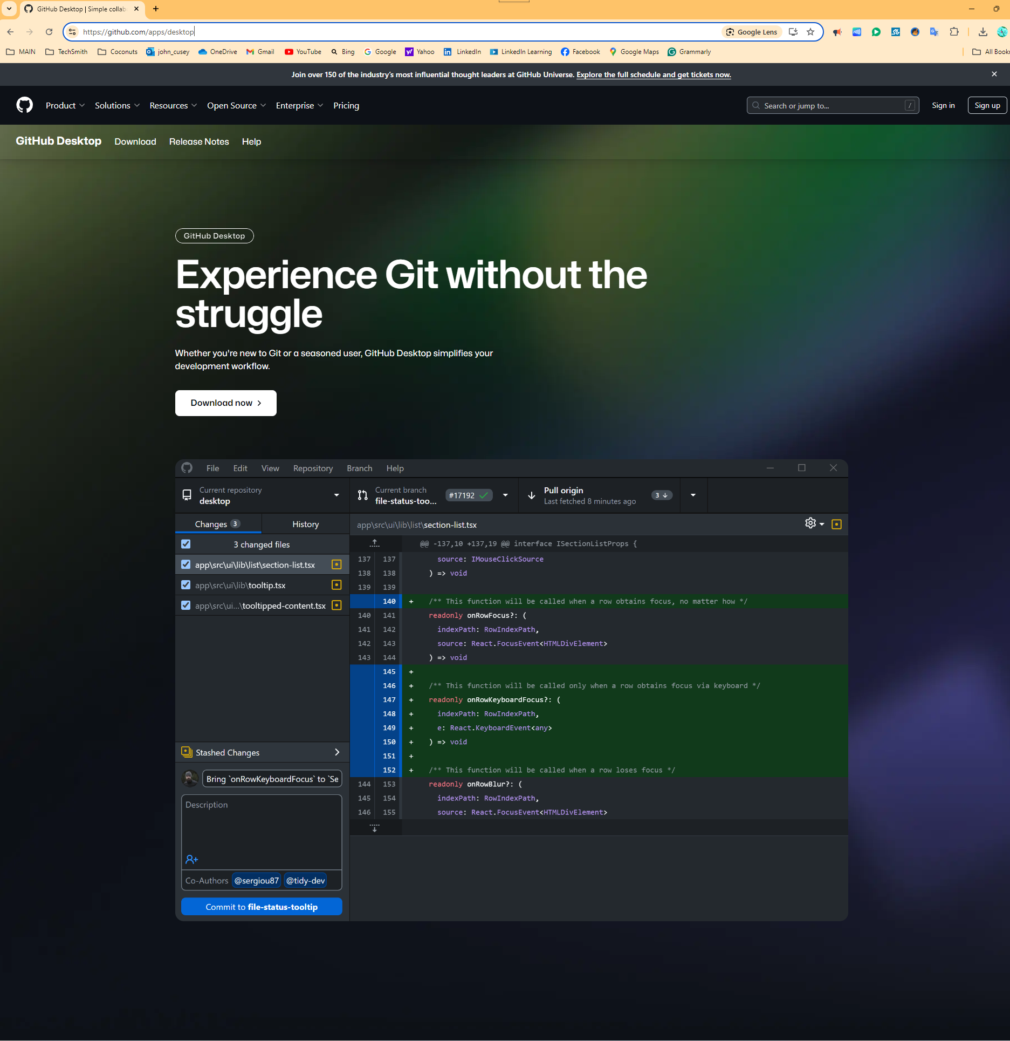
https://github.com/apps/desktop

Visual Studio Code
Visual Studio Code, often referred to as VS Code, is a free, lightweight, yet powerful source-code editor developed by Microsoft. The key features are Integrated debugging tools, Syntax Highlighting for helps in reading and understanding code, Intelligent Code Completion for suggests code completions based on context, reusable pieces of code Snippets, Code Refactoring tools to restructure code without changing its behavior, and Version Control built-in support for Git.
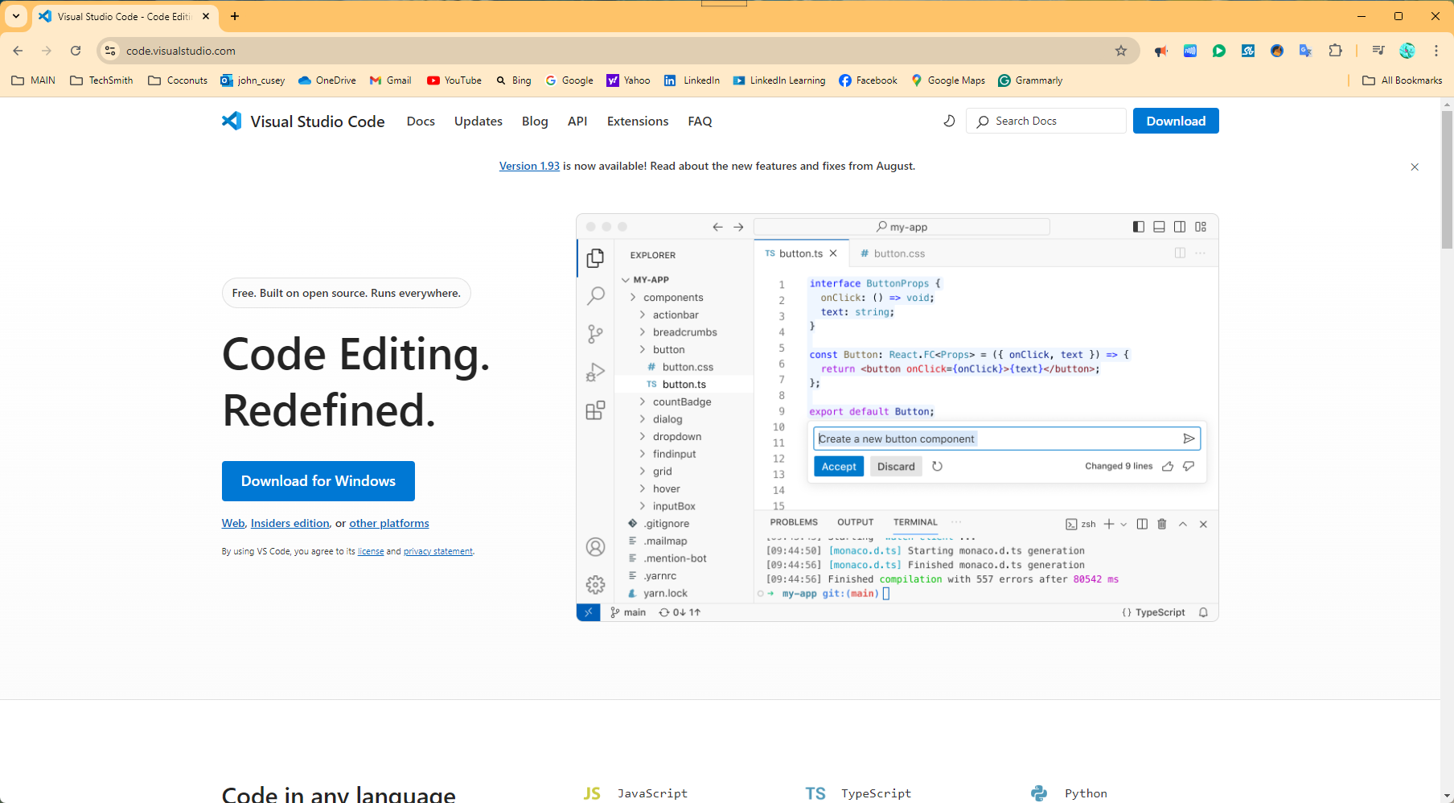
https://code.visualstudio.com/

First Steps creating Repository

Creating new GitHub Repository
A Git repository is a virtual storage space for your project. It allows you to save versions of your code, track changes, and collaborate with others. Here are some key points about Git repositories:
- Version Control: Git helps you keep track of every change made to your codebase, allowing you to revert to previous versions if needed.
- Collaboration: Multiple developers can work on the same project simultaneously without overwriting each other’s work.
- Branching and Merging: You can create branches to work on new features or fixes independently and merge them back into the main codebase when ready.
- Distributed System: Every developer has a full copy of the repository, including its history, which enhances collaboration and redundancy.
You can identify it by the URL from the GitHub homepage. You’ll see “GitHub” followed by your chosen GitHub Account Name. For example, my GitHub site is named “progressive pull.”
https://github.com/progressivepull
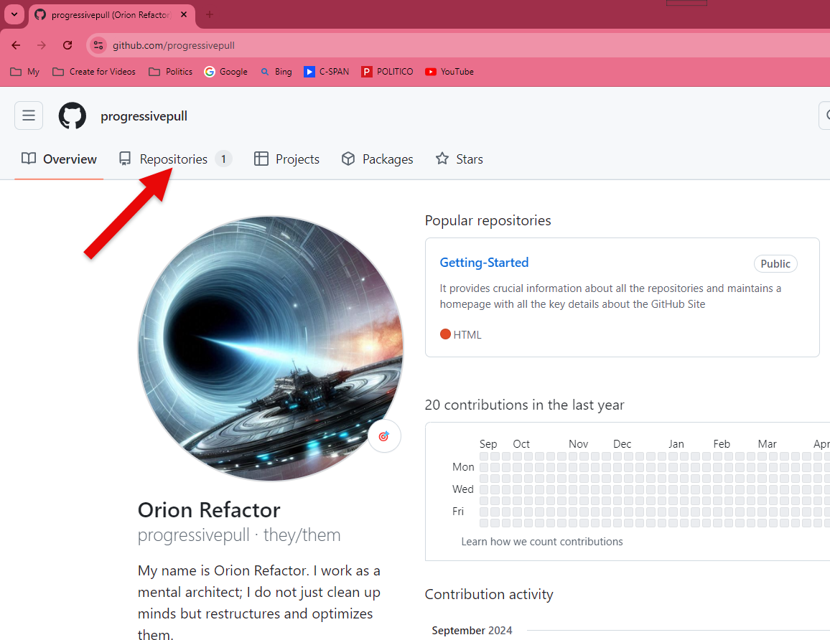
Figure 1.0
Within GitHub, you have entities called repositories. To create a new repository, click on the “Repositories” tab under the GitHub Account Name to access all your repositories. (see Figure 1.0) Here, you’ll find options like Overview, Repositories, Projects, Packages, and Stars.

Deciding on Name for New Repository
The 'Getting Started' repository, often named with generic titles, is a Getting Started for visitors to the GitHub Site. It provides crucial information about all the repositories and maintains a homepage with all the key details about the GitHub Site.
In my 'Resources' repository, I centralize documents and images from all the repositories. I use uppercase names for materials shared across multiple repositories and lowercase names for self-contained repositories.
For experimental codebases, I prefer generic names like 'JavaScript.' However, I've found that using specific names for more comprehensive projects, such as the 'rock, paper, scissors' project involving multiple technologies like JavaScript and Docker, significantly boosts productivity.
The ‘rock-paper-scissors’ project is not just an experimental codebase; it's a fully functional project. You can download and use it to build other projects, such as a banking app. This approach keeps the codebase clean while providing detailed documentation and debugging information in a separate, easily accessible format. By using specific names for different types of codebases, I can quickly identify the contents and purpose of each repository.
This project will generate a web page using a JSON object. The JSON object holds all the comments and debugging information I use to create the web page.

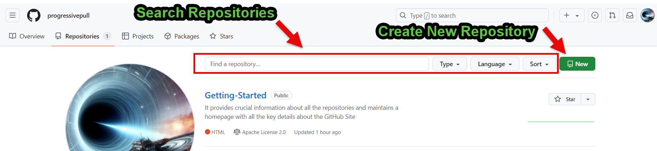
Figure 1.1

You can search for repositories from this section and create a new one. After making a repository, go to the “Settings” tab to delete it. Later in this guide, I’ll guide you through the deleted repository. After clicking the Green New Button, you go to the Create a new Repository Screen.

Create a New Repository
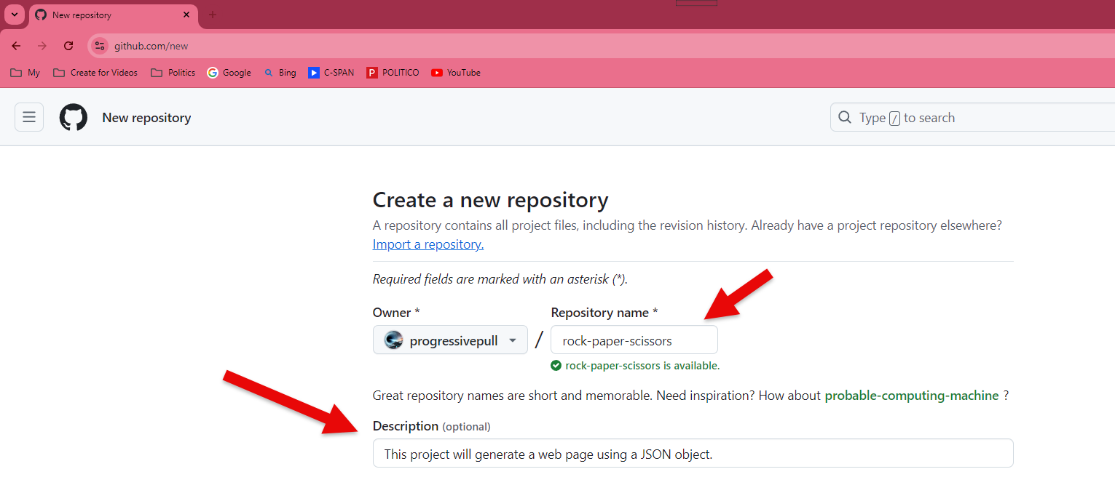
Figure 1.2

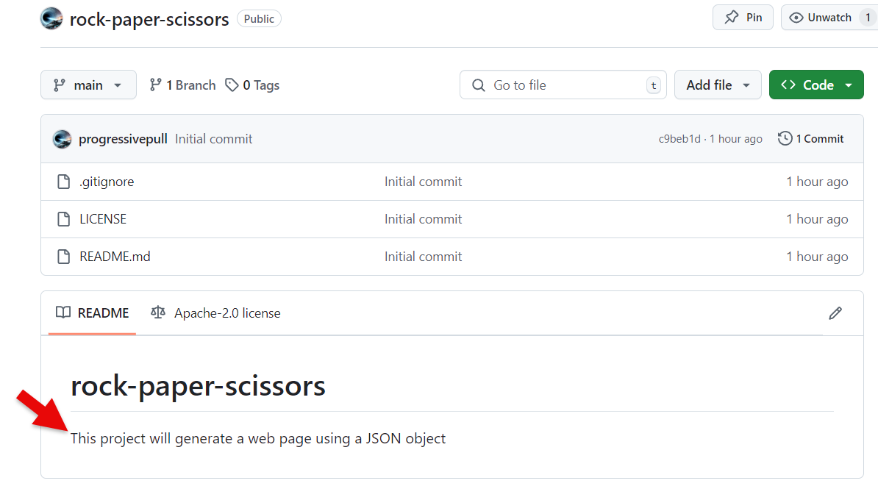
Figure 1.3

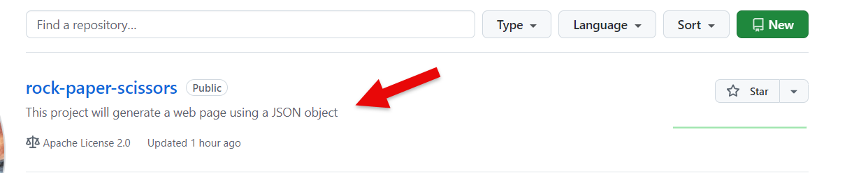
Figure 1.4

Next, you need to name your repository. I’ll call mine “rock-paper-scissors” (note that spaces aren’t allowed in repository names). I also recommend adding a short description (see figure 1.2) My Description for this project is as follows “This project will generate a web page using a JSON object”. Which will appear in your README file (see figure 1.3) if you check the Add a README file (see figure 1.5)

Select Public Type, Initialize README, Git Ignore, License
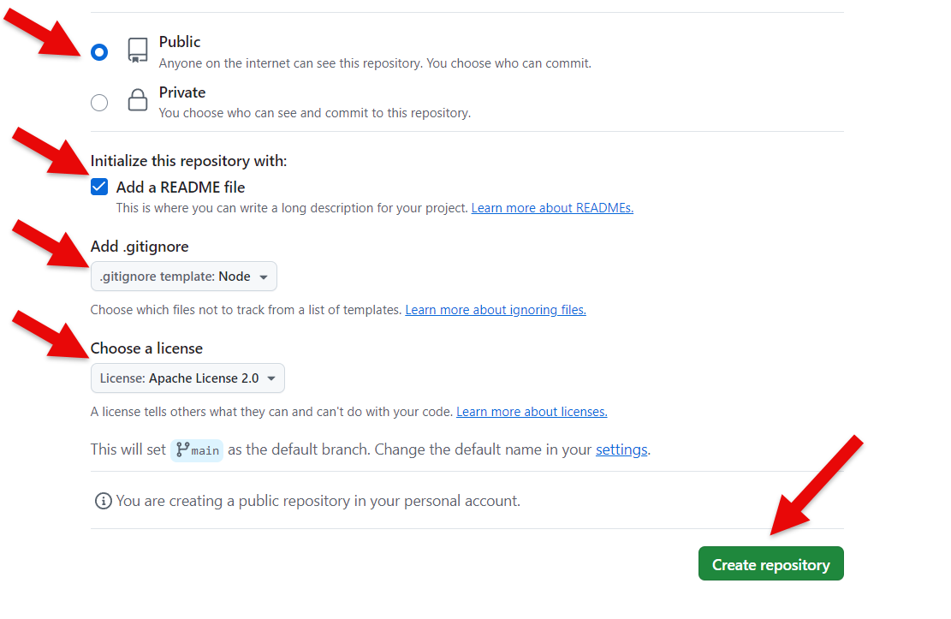
Figure 1.5
I always choose to have a public repository because you can only have one private repository per GitHub account. Then, I check the “Add a README file” option. If you don’t add the README file now, you’ll have to do it manually later. Since this is a JavaScript project, I added a .gitignore file for Node.js. Finally, I select the Apache License and click the big green “Create” button at the bottom of the screen.
A .gitignore file is a configuration file used in Git to specify which files and directories should be ignored by Git. This means that Git will not track changes to these files, and they won’t be included in commits. Here are some key points about .gitignore:
- Purpose: It helps keep your repository clean by excluding files that are not necessary to track, such as temporary files, build artifacts, and sensitive information.
- Syntax: Each line in a .gitignore file specifies a pattern for files or directories to ignore. For example, *.log will ignore all .log files, and temp/ will ignore the temp directory.
- Location: The .gitignore file is usually placed in the root directory of your repository, but you can also have additional .gitignore files in subdirectories for more granular control.
- Global Ignore: You can also set up a global .gitignore file to ignore files across all your repositories.

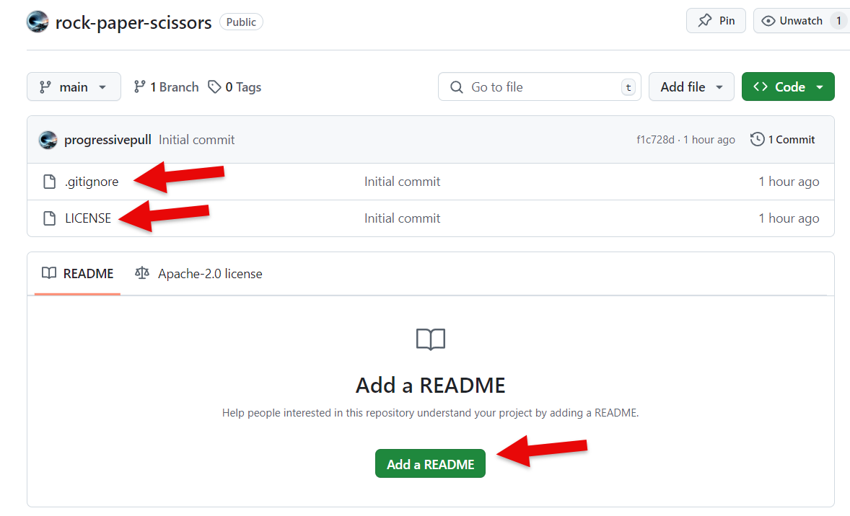
Figure 1.6
When you add the .gitignore and license files, you’ll see a Green Button at the bottom of the page that says, “Add a README file.” (see Figure 1.6)

When you Added no files to Repository
If you create a private repository with a name and description but don’t initialize it with a README file, .gitignore file, or license, and you add no files, you’ll see the follow (Figure 1.7). You can add files using the GitHub Desktop application, drag and drop files into the repository, or use the Git tool to commit files. Alternatively, you can delete the repository and start over. These are your choices for managing the repository.
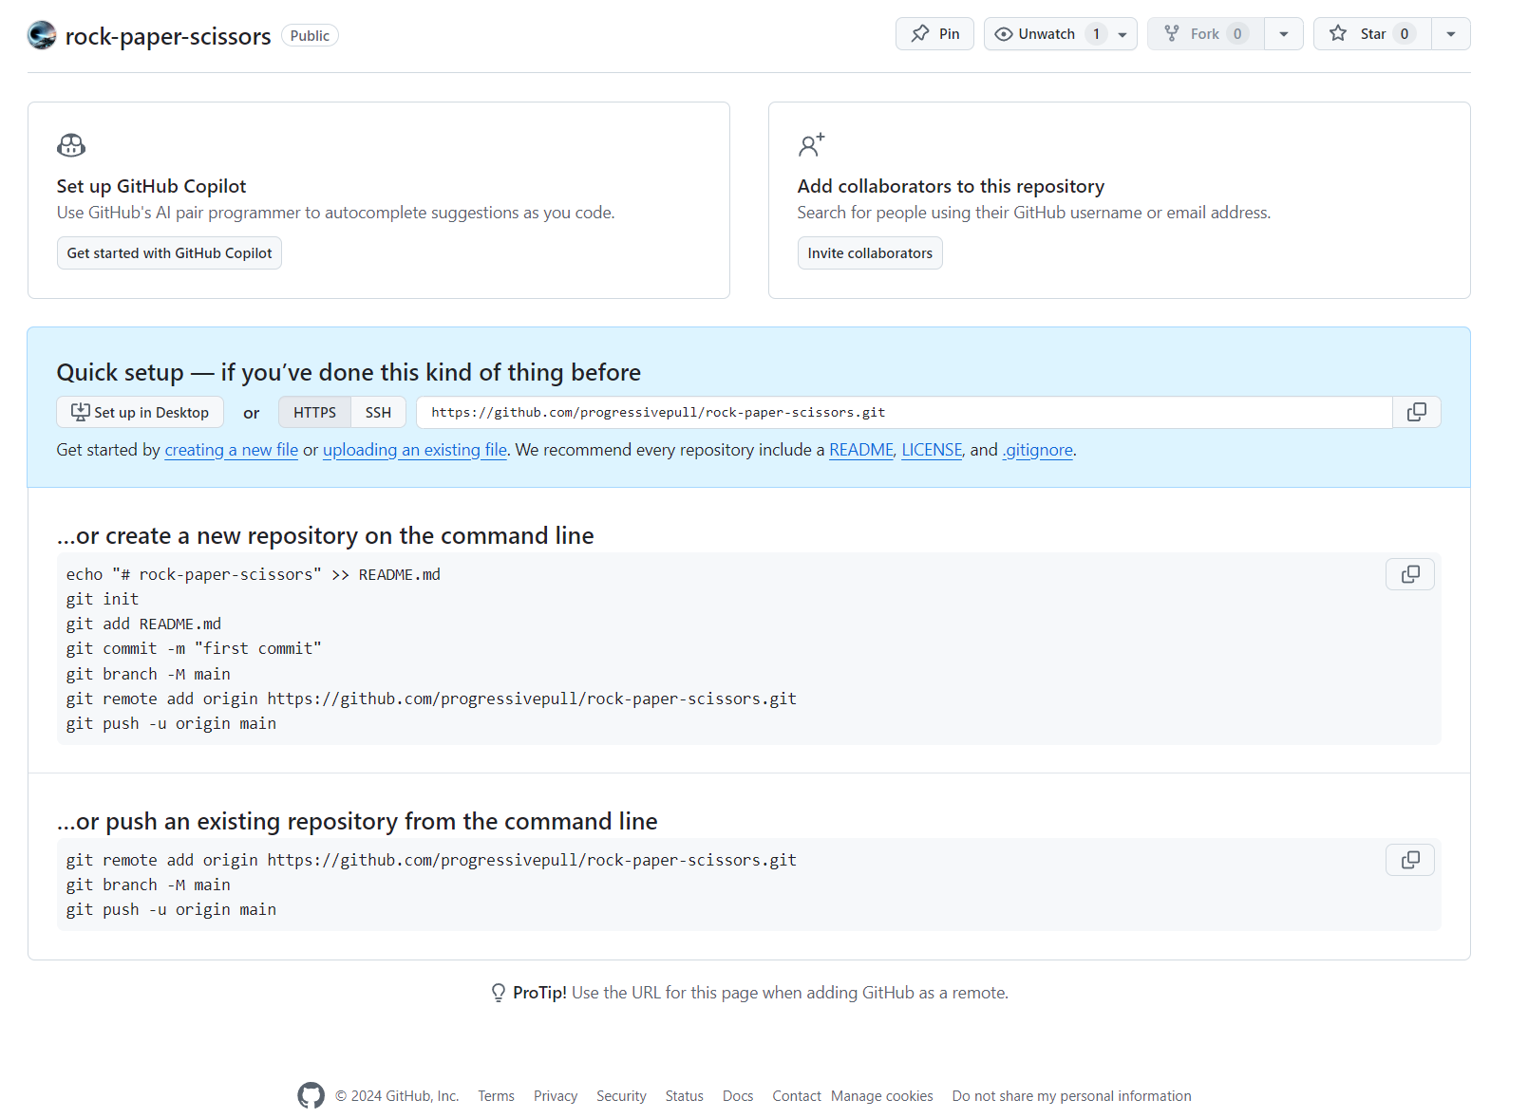
Figure 1.7

or create a new repository on the command line
echo "# rock-paper-scissors" >> README.md
git init
git add README.md
git commit -m "first commit"
git branch -M main
git remote add origin https://github.com/progressivepull/rock-paper-scissors.git
git push -u origin main

or push an existing repository from the command line
git remote add origin https://github.com/progressivepull/rock-paper-scissors.git
git branch -M main
git remote add origin https://github.com/progressivepull/rock-paper-scissors.git
git push -u origin main

create a new repository on the command line tutorial

Open Visual Studio Code
Create a new folder for your repository. I’ll make a folder named rock-paper-scissors on my desktop and open it with Visual Studio Code. You can either click the ‘Open Folder’ button or navigate to File > Open Folder from the main menu.
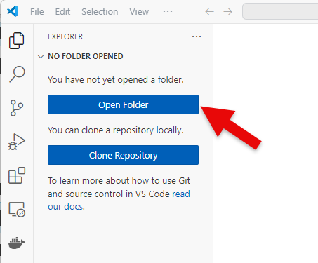

Open Terminal Window
To open the terminal window, go to the main menu and select Terminal > New Terminal. If you have Git installed, you’ll have access to Git Bash. Open the terminal, then use the dropdown to select Git Bash. This allows you to use Linux commands if you’re comfortable with them. Alternatively, you can stick with PowerShell.
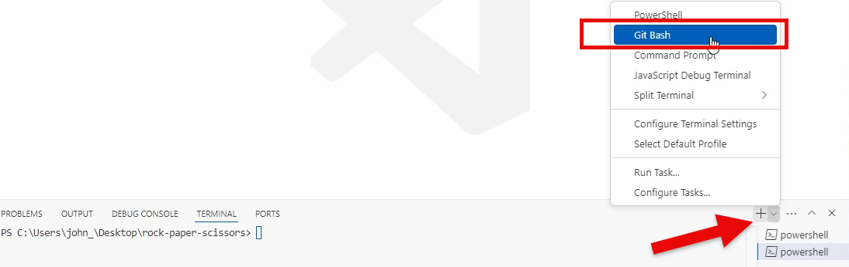

Create README with Echo (echo <text> >> <file_name>)
The following command creates a new README file and writes # rock-paper-scissors to it. This text is written in Markdown. For more information about Markdown, refer to the reference listed at the end of this document.
echo "# rock-paper-scissors" >> README.md
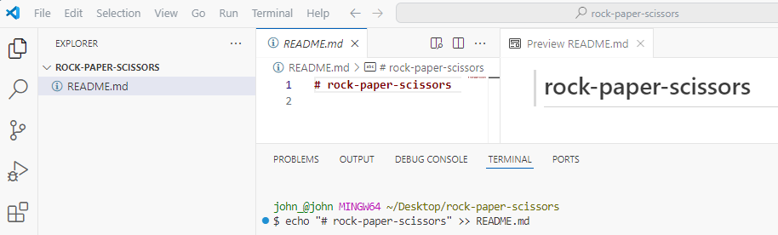

Initialize the Git Repository (git init)
The command git init initializes a new Git repository in your current directory. This means it sets up all the necessary files and structures for version control, allowing you to start tracking changes to your project. The ls -al command in Unix/Linux lists all files and directories in the current directory, including hidden ones, in long format. Refer to refences Linux Commands for details about the ls command at the end of this document.
git init
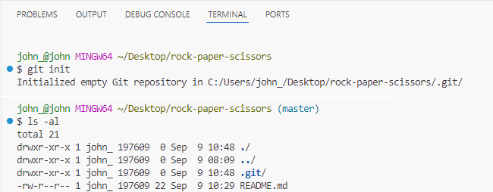

Staging the README File (git add <file_name>)
The command git add README.md stages the README.md file, marking it for inclusion in the next commit. This means any changes made to README.md will be recorded in the repository the next time you run git commit. In Git, “staging” refers to the process of preparing changes for a commit. When you stage a file, you add it to the staging area, also known as the index. This allows you to selectively choose which changes you want to include in your next commit.
git add README.md
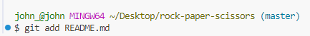

Check what files are Staged
To see which files are staged in Git, you can use the following commands:
- List staged files with changes:
git diff - - staged
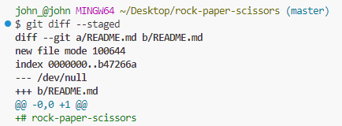
This command shows the differences between the staged changes and the last commit.
- List only the names of staged files:
git diff --name-only - -staged
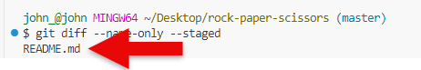
This command lists the names of the files that are staged for the next commit¹².
- Check the status of your repository:
git status

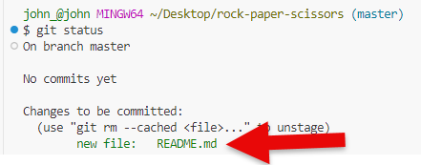

Committing the staged files (git commit -m “<message>”)
The command git commit -m "first commit" creates a new commit with the message “first commit.” This command saves your changes to the local repository with a descriptive message, which helps you and others understand what changes were made in this commit.
git commit -m "first commit"
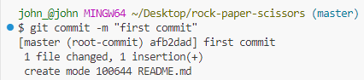

Using Source Tree to check the Git History
First, open SourceTree. Then, navigate to File > Open. From there, browse to the folder containing your Git repository. For example, mine is located at the following.
C:\User\john_\Desktop\rock-paper-scissors
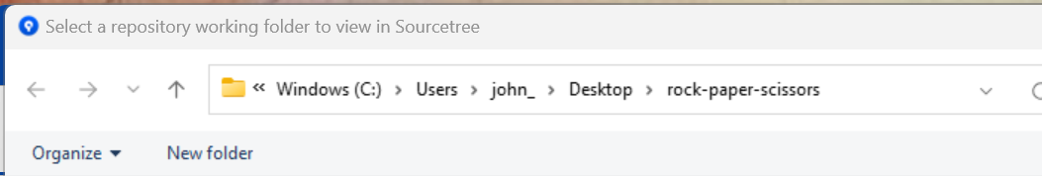

Or to bookmark the Git repository click on the Add Button.
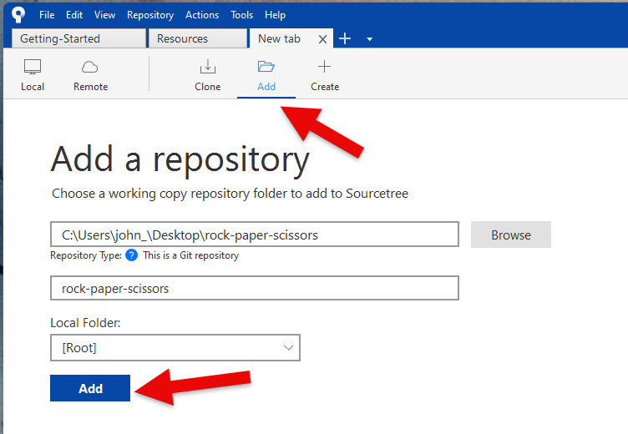

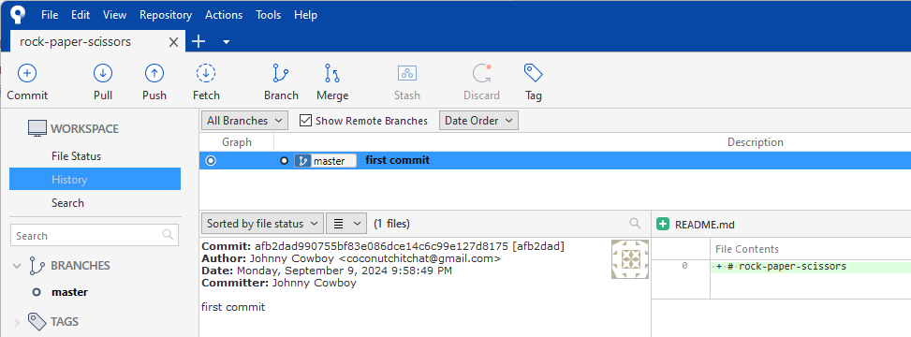

Creating Main Branch
The git branch command is a versatile tool in Git that allows you to manage branches in your repository. Branches in Git allow you to work on different parts of a project simultaneously without interfering with the main codebase. This makes it easier to manage and integrate changes.

Basic Branch Tasks
Here are some of its primary uses:
- Listing Branches: You can list all the branches in your repository using git branch. The current branch will be highlighted with an asterisk.
- Creating Branches: You can create a new branch with git branch <branchname>. This is useful for starting new features or experiments without affecting the main codebase.
- Deleting Branches: You can delete a branch with git branch -d <branchname> if it’s no longer needed.
- Renaming Branches: You can rename a branch with git branch -m <newbranchname>.

Switch between Branches
To switch branches in Git, you can use the git switch command. This command is a more intuitive alternative to git checkout for switching branches. Here’s how you can use it:
- Switch to an Existing Branch:
git switch <branch-name>
This command switches to the specified branch.
- Create and Switch to a New Branch:
git switch -c <new-branch-name>

Merge Branches
The git merge command is used to combine changes from one branch into another. Here’s how you can use it:
- Switch to the Target Branch:
- git switch <target-branch>
This is the branch you want to merge changes into.
- Merge the Source Branch:
- git merge <source-branch>
This command merges the specified source branch into the current branch.
Example
If you want to merge a branch named feature into main, you would do the following:
git switch main
git merge feature
Handling Merge Conflicts
Sometimes, you might encounter merge conflicts. Git will notify you of conflicts, and you’ll need to resolve them manually. After resolving conflicts, you can complete the merge with:
git add <resolved-files>
git commit
Fast-Forward Merge
If the target branch has not diverged from the source branch, Git will perform a fast-forward merge, simply moving the pointer forward.

Rename Branch (git branch -M <branch_name>)
The command git branch -M main is used to rename the current branch to main. Here’s a breakdown of what it does:
- git branch -M: The -M option is a shorthand for --move --force. It renames the branch and forces the rename even if the new branch name already exists.
- main: This is the new name for the branch.
This command is often used to rename the default branch from master to main, which has become a more inclusive naming convention.
git branch -M main
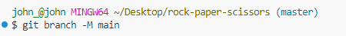
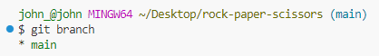

Delete a Repository
First, navigate to the GitHub Account Home Page. Select the repository you wish to delete. For example, I want to delete the rock-paper-scissors repository.
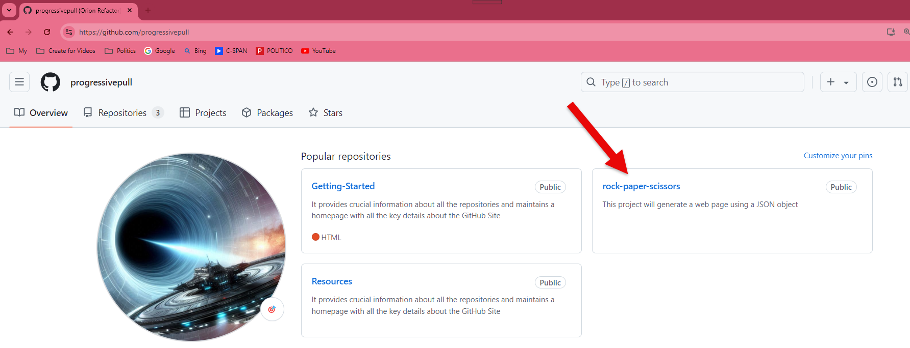

Next, click on Settings in the navigation bar to access the General configuration.
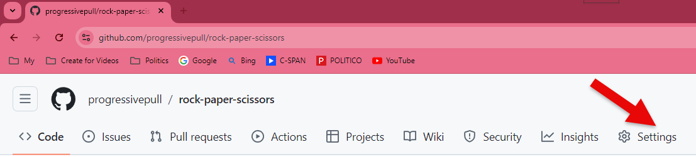

Scroll to the bottom of the page to the Danger Zone section and click on the Delete this repository button and follow the prompts.
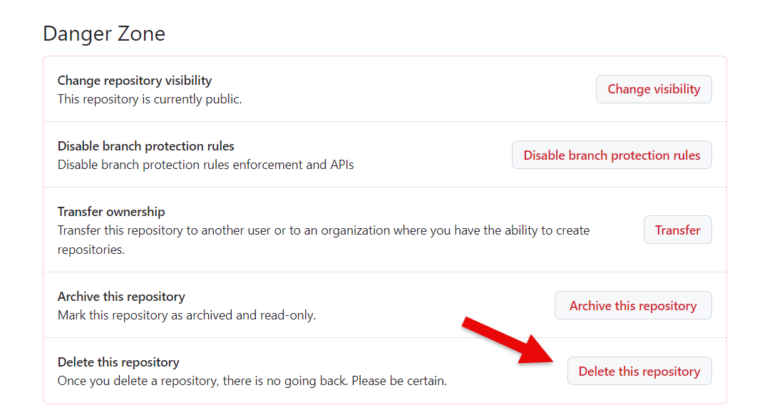

README File
A README file is a document typically included in a project or repository (often with the filename README.md for markdown formatting) that provides essential information about the project. A README file might include the following:
1. Project Overview
- A brief description of what the creative project is about.
- The purpose or goal of the project (e.g., personal portfolio, collaborative art, open-source design resources).
2. Usage Instructions
- How to view or interact with the project.
- Any prerequisites or dependencies needed to view or run the project files (e.g., specific software or tools).
3. Content Description
- A list or explanation of the contents of the project (e.g., folders for images, scripts, text files).
- File types and formats used (e.g., .png for images, .mp3 for music).
4. Credits and Attribution
- The creators or contributors to the project.
- Any third-party assets used (e.g., fonts, stock images, sound effects) and their licenses.
5. Contribution Guidelines (if applicable)
- How others can contribute to the project (e.g., for collaborative artwork or open-source design).
6. Licensing
- Information about how the project can be used by others (e.g., under a Creative Commons license).
7. Contact Information
- Ways to get in touch with the creator or team for further information, collaboration, or support.
For example, in a creative project focused on visual art, the README could include instructions on how to properly display the images, any required tools (like a specific image viewer or web framework), and how to contribute additional artwork to the project.

References

Markdown
- https://www.markdownguide.org/
- https://commonmark.org/help/
- https://dillinger.io/

Linux Commands
- https://phoenixnap.com/kb/linux-commands-cheat-sheet
- https://www.loggly.com/wp-content/uploads/2015/05/Linux-Cheat-Sheet-Sponsored-By-Loggly.pdf
- https://www.digitalocean.com/community/tutorials/linux-commands

